ECE 425
Christer Hoeflinger
Ian Miller
4/18/2017

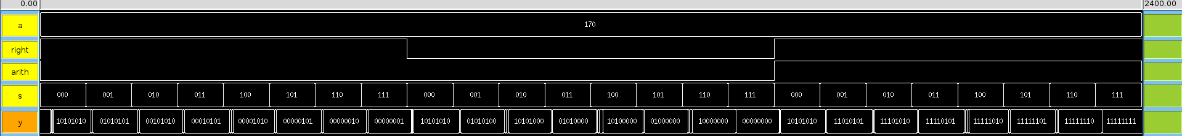Figure 1: 10101010 Shift Test

Here is the first waveform of our test for the logarithmic shifter. The original number was a binary 10101010. We tested the functionality by shifting left, right logical, and right arithmetic by all possible shift amounts. The test passed with no errors printing out.

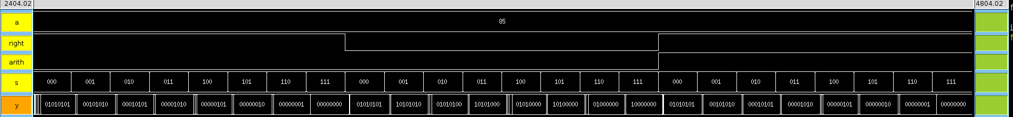Figure 2: 01010101 Shift Test

This test was completed in the same manor as the first but with the number 01010101. This was done to show the arithmetic shift will grab the sign bit correctly for both a 1 and a 0. This test passed as well.

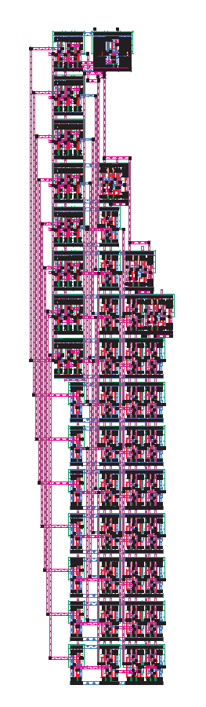Figure 3: Shifter Layout
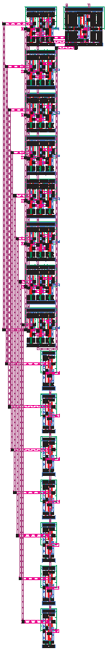Figure 4: Source Generator
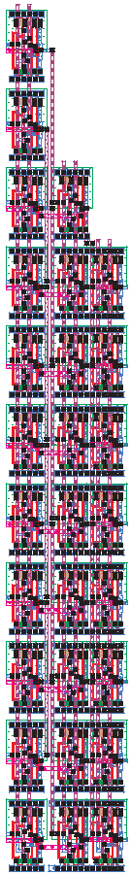Figure 5: Mux Shifting

This is the layout of the logarithmic shifter. We were able to make it slightly smaller than our original estimate in the vertical direction, and match horizontally. It is designed to use abutment to connect into the ALU and be used in the datapath. The source generator and mux shifting sections that make up the entire shifter are shown as well.

